5.105: a) Newton’s 2nd law gives
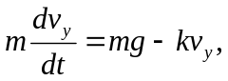 where 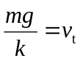
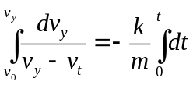
This is the same expression used in the derivation of Eq. (5.10), except the lower limit in the velocity integral is the initial speed  instead of zero.
Evaluating the integrals and rearranging gives
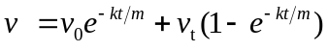
Note that at  this expression says 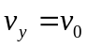 and at 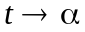 it says 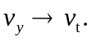
b) The downward gravity force is larger than the upward fluid resistance force so the acceleration is downward, until the fluid resistance force equals gravity when the terminal speed is reached. The object speeds up until 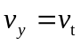. Take 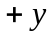 to be downward.

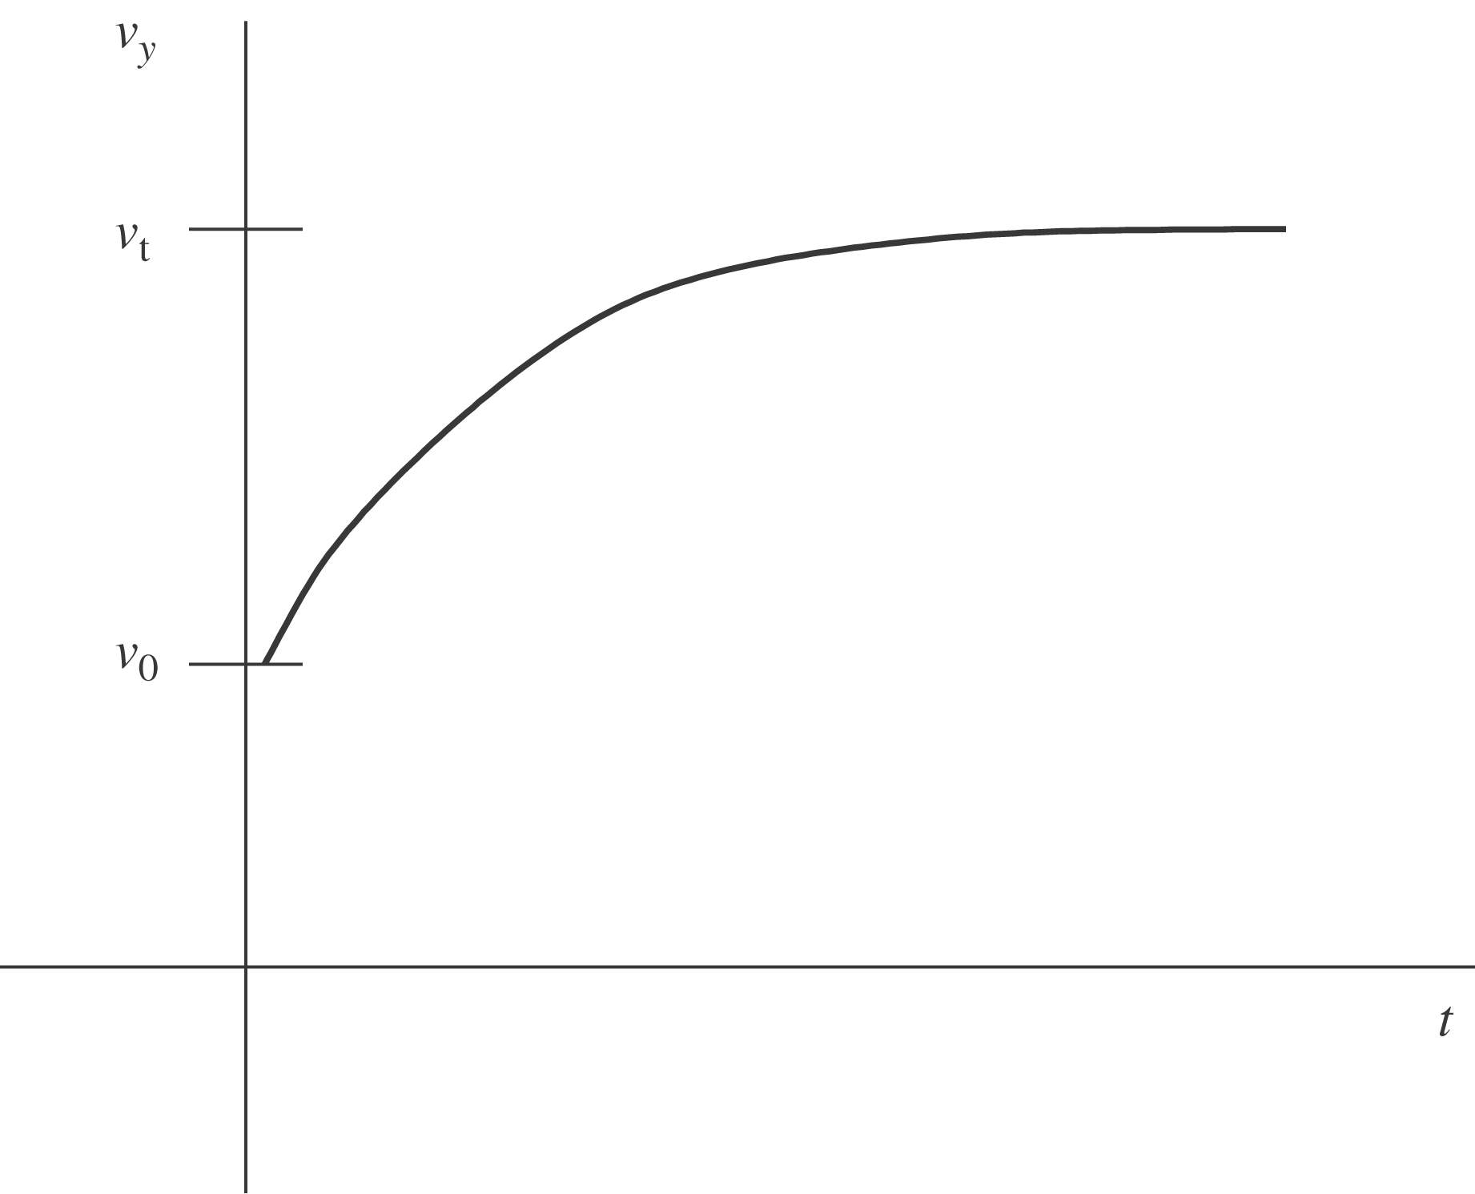

c) The upward resistance force is larger than the downward gravity force so the acceleration is upward and the object slows down, until the fluid resistance force equals gravity when the terminal speed is reached. Take to be downward.
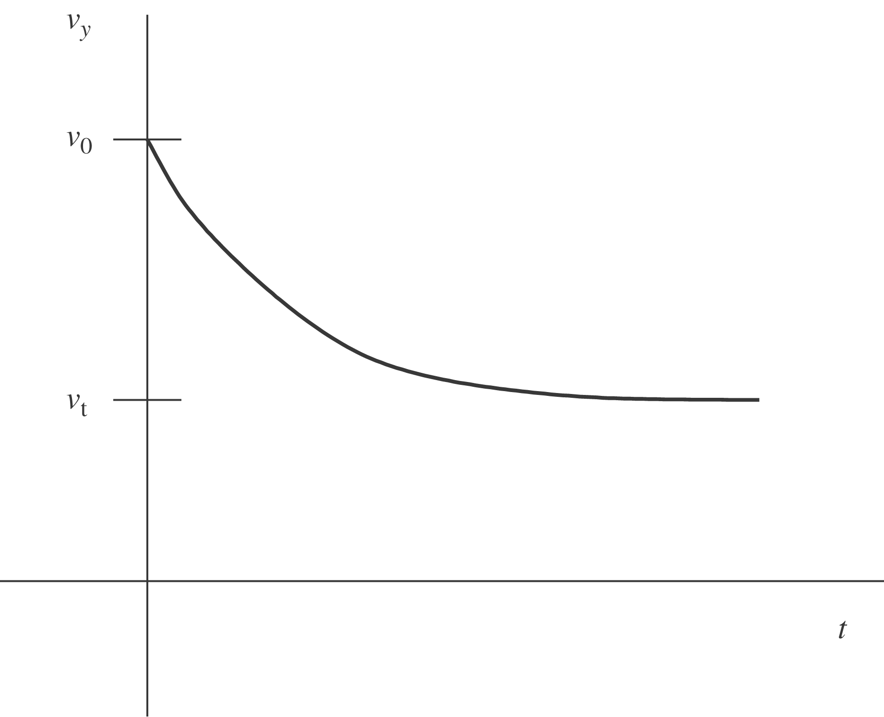

d) When 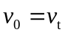 the acceleration at 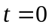 is zero and remains zero; the velocity is constant and equal to the terminal velocity.

